Title
First Author¹ and Second Author²
¹ orcidID, Karadeniz Technical University, Civil Engineering Department, Trabzon, Türkiye, first.author@ktu.edu.tr
² orcidID, Eastern Mediterranean University, Civil Engineering Department, North Cyprus, Türkiye, second.author@emu.edu.tr

Abstract. The abstract should present a concise summary of the study, including its objectives, scope, and results, in fewer than 250 words. Additionally, the authors are required to provide their ORCID IDs and email addresses in the affiliations section.

Keywords: Provide minimum of three keywords.

- First Section
The manuscript length must not exceed 10 pages. It must be formatted using Times New Roman 12-point font, single-line spacing, and 2.5 cm margins on A4 paper. Submissions must be exclusively in .docx format, named as “ACE2026-XXX-001.docx”; PDF files will not be accepted.
In-text citations should be formatted with numbers in square brackets ([1], [2-4]). References must preferably be limited to a maximum of 20 sources. The bibliography at the end of this text provides a sample listing for journal articles [1], conference proceedings [2], books [3], proceedings without editors [4], and URLs [5]. Include DOI numbers when available.
Each manuscript will undergo plagiarism screening and must achieve a similarity index of 20% or less. The authors are responsible for ensuring the originality of their work. Additionally, the authors must specify their contributions (e.g., Conceptualization, Methodology, Writing) at the end of the document in a separate section. If the manuscript contains many abbreviations, an abbreviation list may be added at the end of the document.

  - A Subsection Sample
Do not indent the first paragraph of a section, subsection, or the first paragraphs that follow a table, figure, or equation.
Use 0.5 cm indentation for the subsequent paragraphs. Each visual element (Figures and Tables) must be referenced in the manuscript. They also should appear in the text near their first mention. All figures should have a minimum resolution of 600dpi. The captions must follow the required format (e.g., Fig. 1, Table 1).

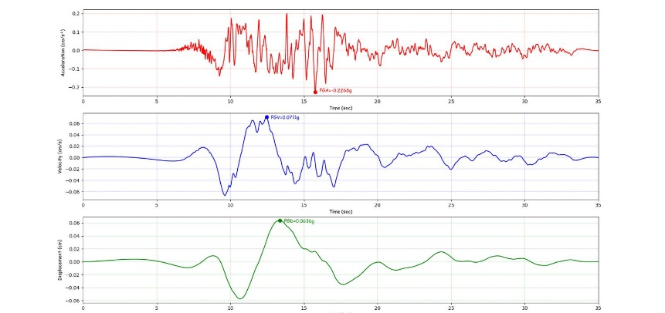
Fig. 1. Figure captions must be placed below the illustration. Center short captions that fit on one line and justify the long ones.

Sample Heading (Third Level). Only number the first two heading levels. Format the lower levels as run-in headings.

Sample Heading (Fourth Level). Do not use headings beyond the fourth level. Table 1 outlines the formats for each heading level.

Table 1. Table captions should be placed above the tables.
Heading level | Example | Font size and style
Title (centered) | Lecture Notes | 16 pt, bold
1st-level heading | 1 Introduction | 12 pt, bold
2nd-level heading | 2.1 Printing Area | 12 pt, bold
3rd-level heading | Run-in Heading in Bold. Text follows | 12 pt, bold
4th-level heading | Lowest Level Heading. Text follows | 12 pt, italic

Equations must be centered and presented on a separate line. They should be created using the Math Type/Microsoft Equation Editor and provided in an editable format.

x + 3y = 5z (1)

Acknowledgments
Acknowledgments will be placed at the end of the text before the references list.

References
- Author 1.: Article title. Journal 2(5), 99–110 (2016).
- Author 1., Author 2.: Title of a proceedings paper. In: Editor, F., Editor, S. (eds.) Survival and Sustainability, pp. 211–219 Springer, Heidelberg (2011).
- Author 1., Author 2., Author T.: Book title. 2nd edn. Publisher, Location (1999).
- Author 1.: Contribution title. In: 9th International Proceedings on Proceedings, pp. 1–2. Publisher, Location (2010).
- ACE2026 Homepage, http://www.ace2026.ktu.edu.tr, last accessed 2026/04/01.

Author Contribution Statement
- Conceptualization: Author name
- Methodology: Author name
- Investigation: Author name 1, Author name 2
- Writing – Original Draft: Author name
- Writing – Review & Editing: Author name

List of Abbreviations
- FEM — Finite Element Method
- CFD — Computational Fluid Dynamics
- UAV — Unmanned Aerial Vehicle
- AI — Artificial Intelligence
- ML — Machine Learning

Appendices
Appendix A. Numerical Model Validation
This appendix provides detailed validation plots of the numerical model used in the study.

Appendix B. Additional Tables
Tables B1–B3 contain extended parameter lists not included in the main text.

Appendix C. Survey Questionnaire
A full version of the questionnaire used for data collection is provided here.

Authors should also declare any conflict of interest, acknowledge funding sources when applicable, and provide data availability or ethical approval statements if required. Optional additions such as a graphical abstract, highlights, a nomenclature list, software/code availability notes, study limitations, or future work descriptions may be included depending on the nature of the research.

Note: Following the conference, this Publication Note will be added to each paper; therefore, authors are kindly requested not to remove the note below and to complete the author(s) and paper title information.
Publication Note
This paper was peer-reviewed, accepted for presentation, and included in the proceedings of the ACE2026 – International Conference on Advances in Civil Engineering, held on 12–14 October 2026 in Trabzon, Türkiye.

This paper may be cited as follows:
Author(s), “Title of the Paper,” in Proceedings of the ACE2026 – International Conference on Advances in Civil Engineering, Trabzon, Türkiye, 12–14 October 2026.

